**Master of Science in Environmental Science**

**Assessing Tributary Effects on Sediment Composition in the Dam-Regulated Dixence River.**

Elias Al Alam

Under the supervision of Prof. Stuart Lane

Under the expertise of Prof. Stuart Lane

**Grande Dixence Dam.** Image taken from "https://www.valais.ch/en/explore/activities/other-summer-activities/dams-tour/grande-dixence"

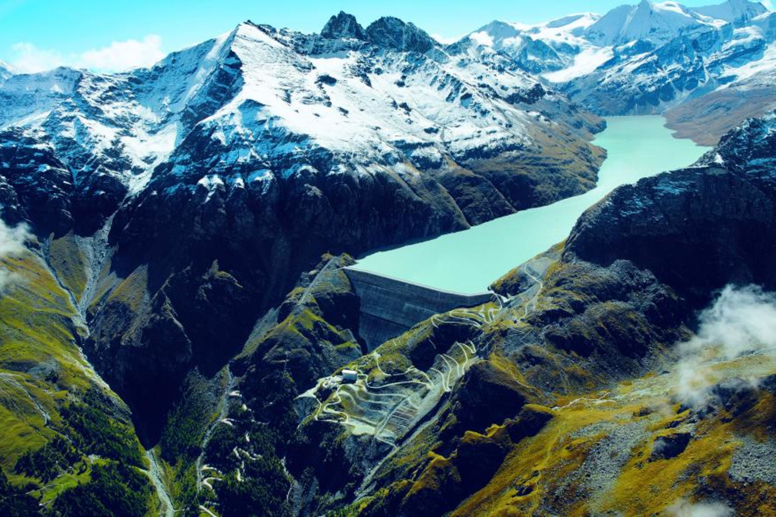

**Director**  Signature